**DAILY ONLINE ACTIVITIES SUMMARY**

|  |  |  |  |  |  |  |  |  |
| --- | --- | --- | --- | --- | --- | --- | --- | --- |
| **Date:** | **16/06/2020** | | | | | **Name:** | **NIKHIL KUMAR** | |
| **Sem & Sec** | **4thSEM. & ‘B’ SEC.** | | | | | **USN:** | **4AL19CS400** | |
| **Online Test Summary** | | | | | | | | |
| **Subject 1** | | **Mathematics 4** | | | | | | |
| **Max. Marks** | | **30** | | **Score** | | | **22** | |
| **Certification Course Summary** | | | | | | | | |
| **Course** | **Introduction to ethical hacking** | | | | | | | |
| **Certificate Provider** | | | **Greatlearning**  **Academy** | | **Duration** | | | **4.0 Hrs.** |
| **Coding Challenges** | | | | | | | | |
| **Problem Statement : write a cpp program to perform the following operation on Triply linked list(TLL).** | | | | | | | | |
| **Status:executed** | | | | | | | | |
| **Uploaded the report in Github** | | | | | **Yes** | | | |
| **If yes Repository name** | | | | | **1.** <https://github.com/Nikhil401/c-codding/blob/master/TLL.cpp> | | | |
| **Uploaded the report in slack** | | | | | **Yes** | | | |

**Online test summary: subject Mathematics 4 test scheduled from 3:00 to 3:40 pm and the given questions were 15 and each carries 2 mark.**

**Snapshot is given below:**

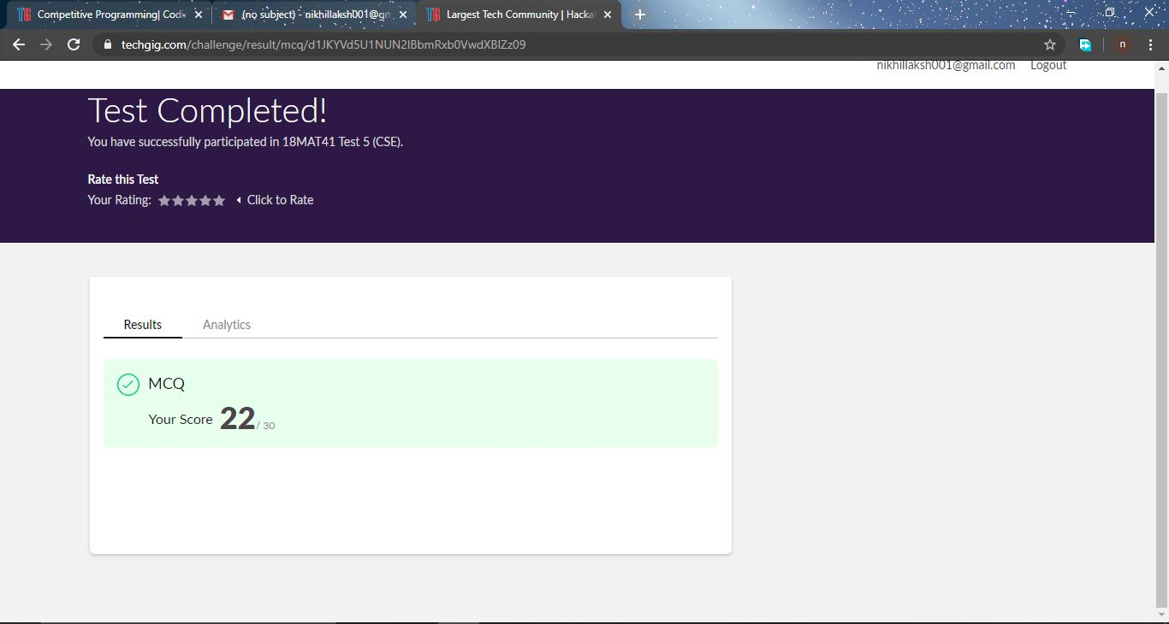

**Certification Course Summary: Today I have learnt something about the Ethical hacking in network Architecture-Demonstration under ethical hacking and the snapshot is given below:**

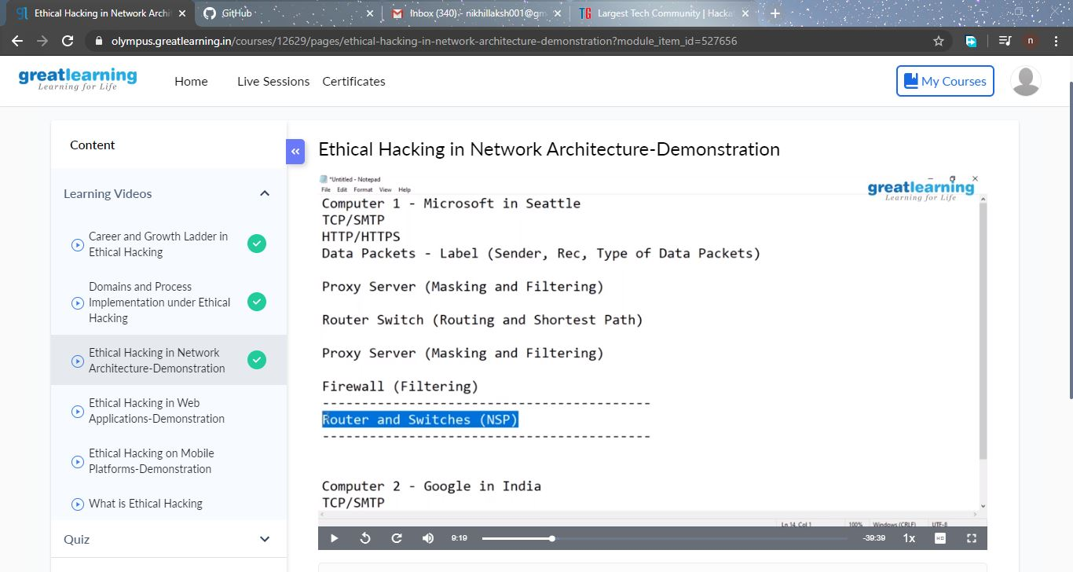

**Online Coding Summary: Today I received one program from prof. Venkatesh CSE Dept. The program is mentioned above(pg.01). to my GitHub repository link and I’ve shared and the snapshot below. 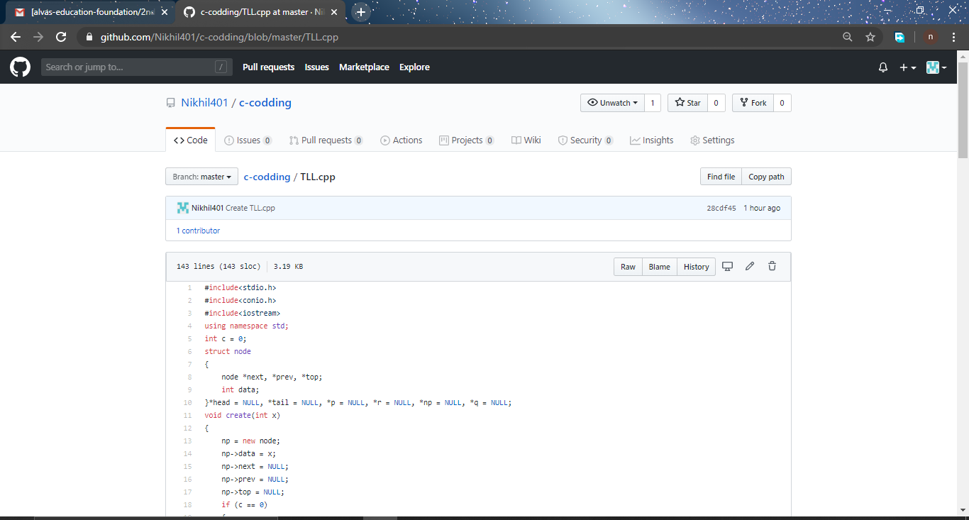Thank you.**